

**Arrange by :**

Kapten Bintang

M Dani Setiawan

Ferdiansyah

**2SC8**

**Faculty :**

M.Hudya Ramadhana

**CCIT Fakultas Teknik-Universitas Indonesia**

**Kampus Baru UI Depok 16424**

**Project On**

BFD Coffee Shop

Developed by

Name : Kapten Bintang

M Dani Setiawan

Ferdiansyah



**BFD Coffee Shop**

Batch Code: 2SC8

Start Date: April 17, 2019

End Date: April 28, 2019

Name of the Coordinator: M. Hudya Ramadhana

Names of Developer:

* Kapten Bintang
* M Dani Setiawan
* Ferdiansyah

Date of Submission: April 28, 2019



**CERTIFICATE**

This is to certify that this report titled BFD Coffee Shop embodies the original work done by, Kapten Bintang,M.Dani Setiawan,Ferdiansyah in partial fulfillment of their course requirement at NIIT.

Coordinator:

M.Hudya Ramadhana





**ACKNOWLEDGEMENT**

Authors would like to praise to Allah, Most Merciful bless and so authors can finish this Project 2 entitled **“BFD Coffee Shop”**. Author would like to thanks to Mr.Hudya Ramadhana as Lecturer who has given useful suggestion which are help author in writing this paper.

The writer realized that this paper far from perfection, then the writer will be very unfettered the chest and was encouraged, if colleagues and the guide's agreeing lecturer gave the suggestion & criticism for this paper perfection.



**SYSTEM ANALYSIS**

**System summary :** BFD Coffee Shop is a simple application for selling coffee,in this application we can see a list of items what we sell on the coffee menu then we can see ordered menu that is,we can see customers who have bought in our coffee and in this menu we will give primary key which is where the function will be used in the next menu,namely transaction menu

**System Processes :** BFD Coffee Shop is a simple application for selling coffee

**CoffeeApp Design**

**Source Packages**

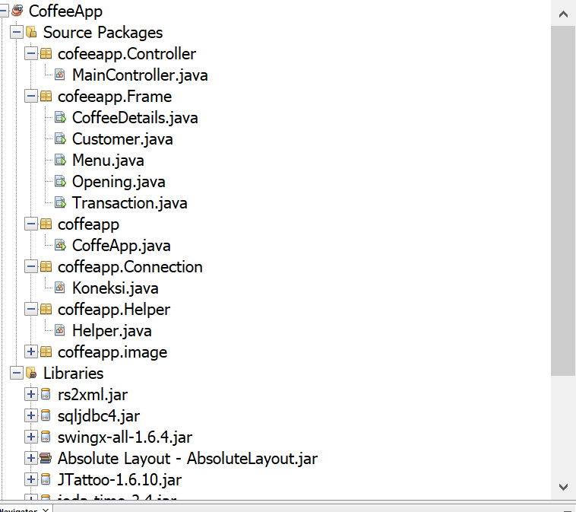

**BFD CoffeeApp**

**OpeningApp**

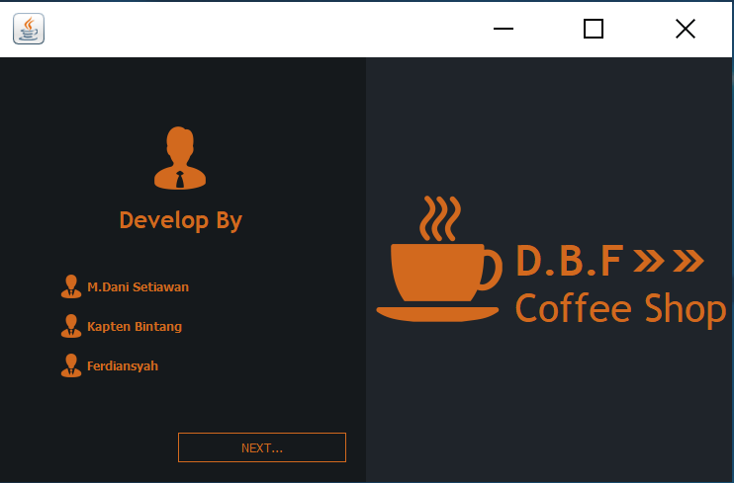

**BFD CoffeeApp**

**Coffee Shop Menu**

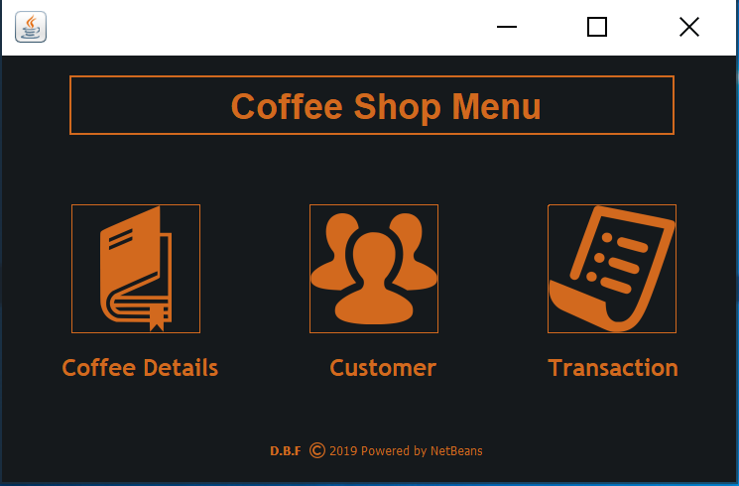

**BFD Coffee App**

**Menu Coffee Detail**

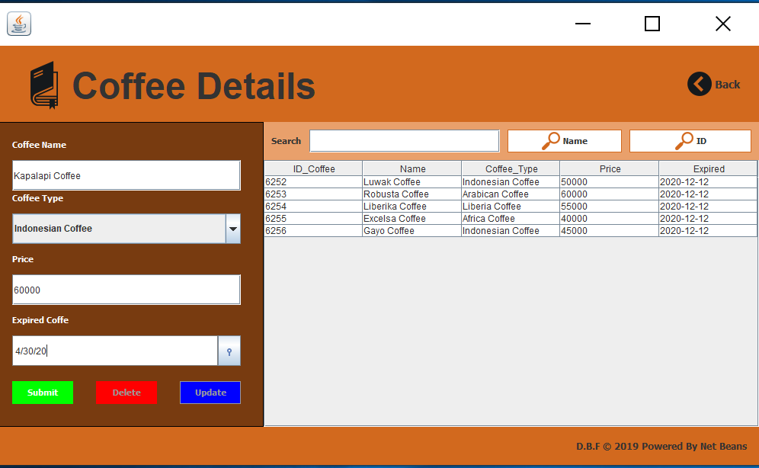

**BFD CoffeeApp**

**Menu Customer**

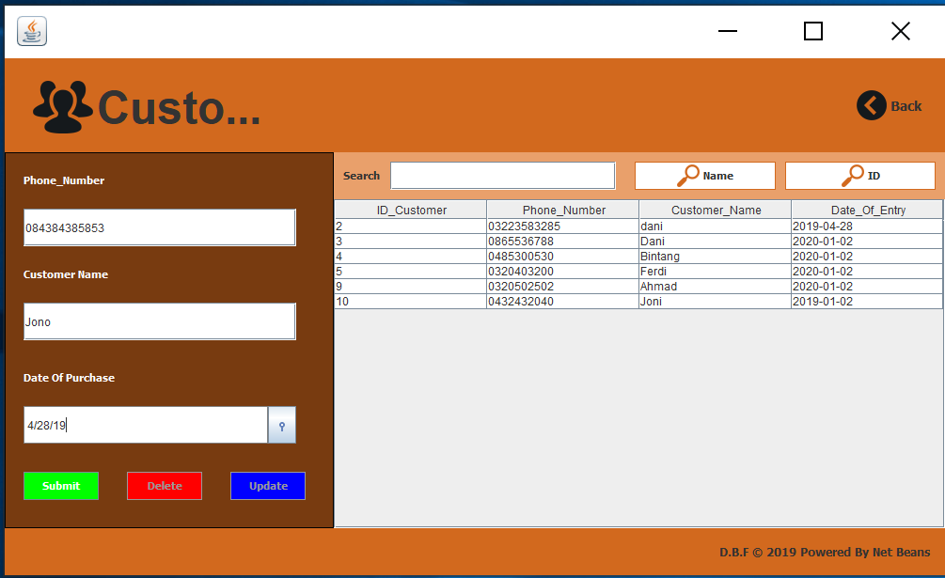

**BFD CoffeeApp**

**Menu Transaction**

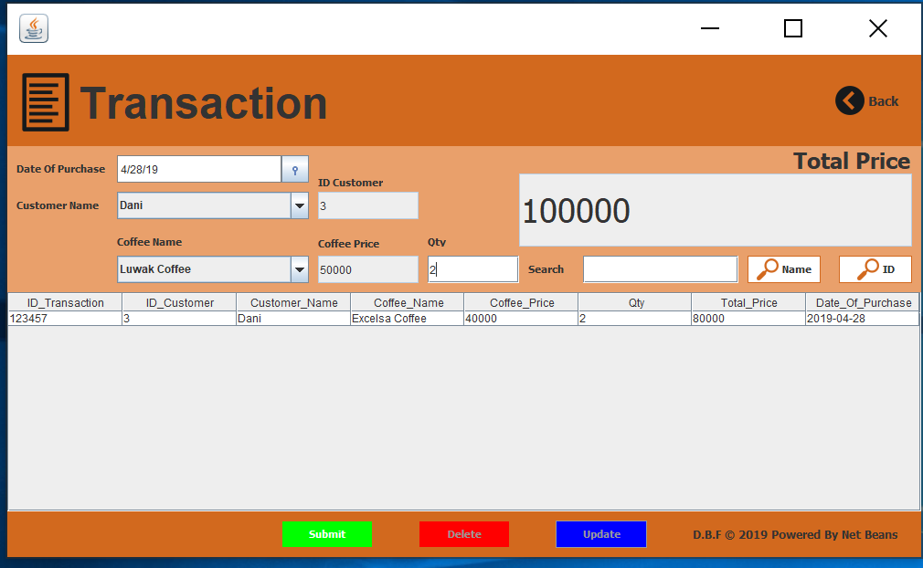

**Hardware** :

PC compatible with an Intel Core – i5 processor, 8 GB RAM and 128 GB of SSD

**Operating System** :

Microsoft Windows 10

**Software** :

Netbeans IDE 8.2

|  |  |  |
| --- | --- | --- |
| **PROJECT FILE DETAILS** | | |
| **S.No** | **File Name** | **Remarks** |
| 1. | .java | The Netbeans Java project that contains transactions that have a database |

**CONFIGURATION**